stg_box_office_worldwide 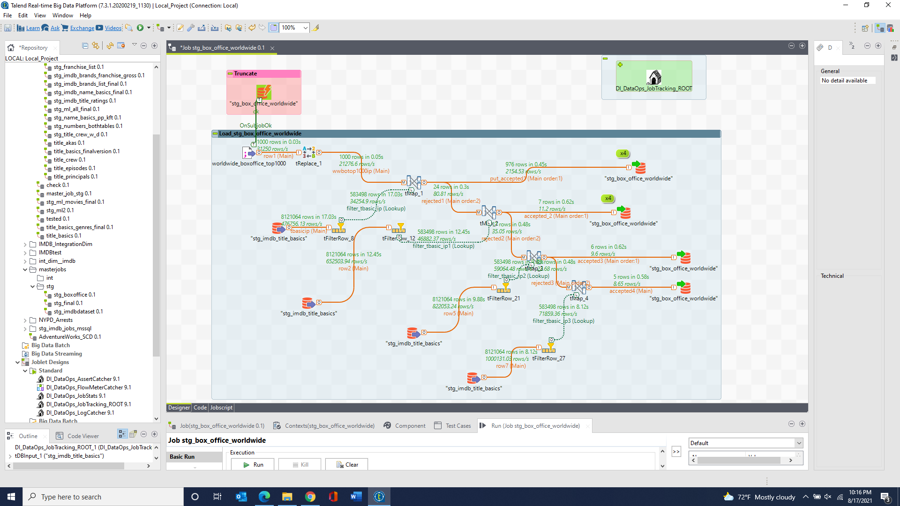

stg_imdb_brands_gross & stg_imdb_franchises_gross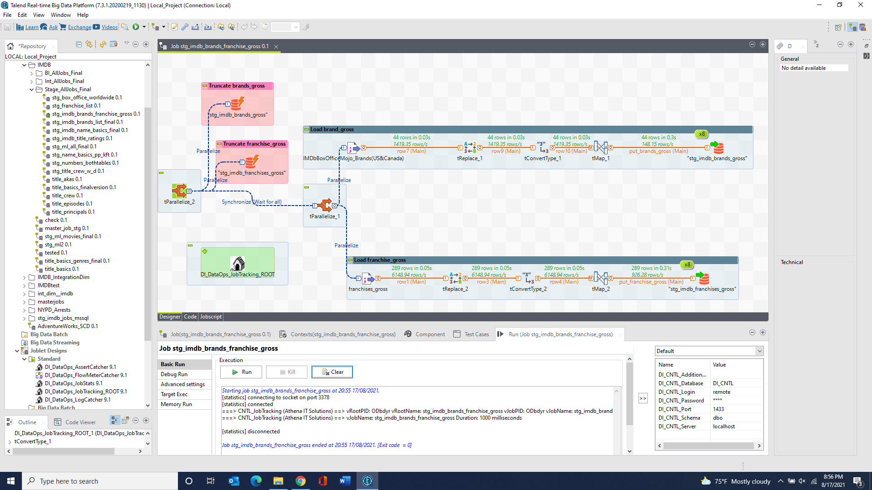

stg_imdb_brands_list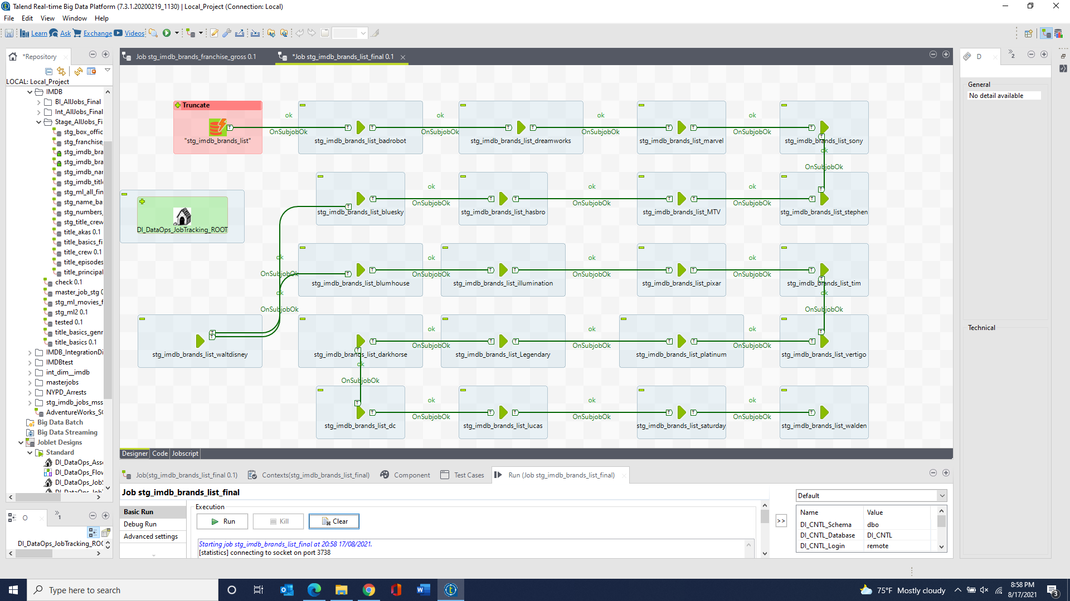

stg_imdb_franchises_list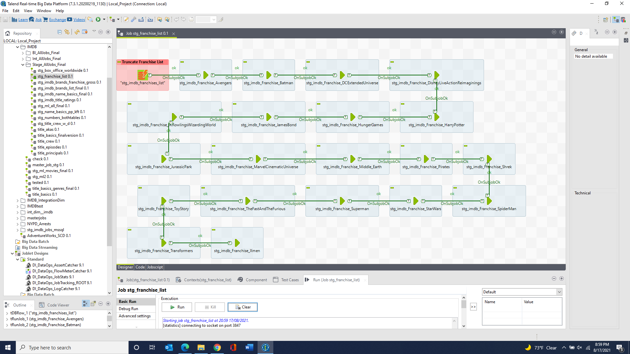

stg_imdb_name_basics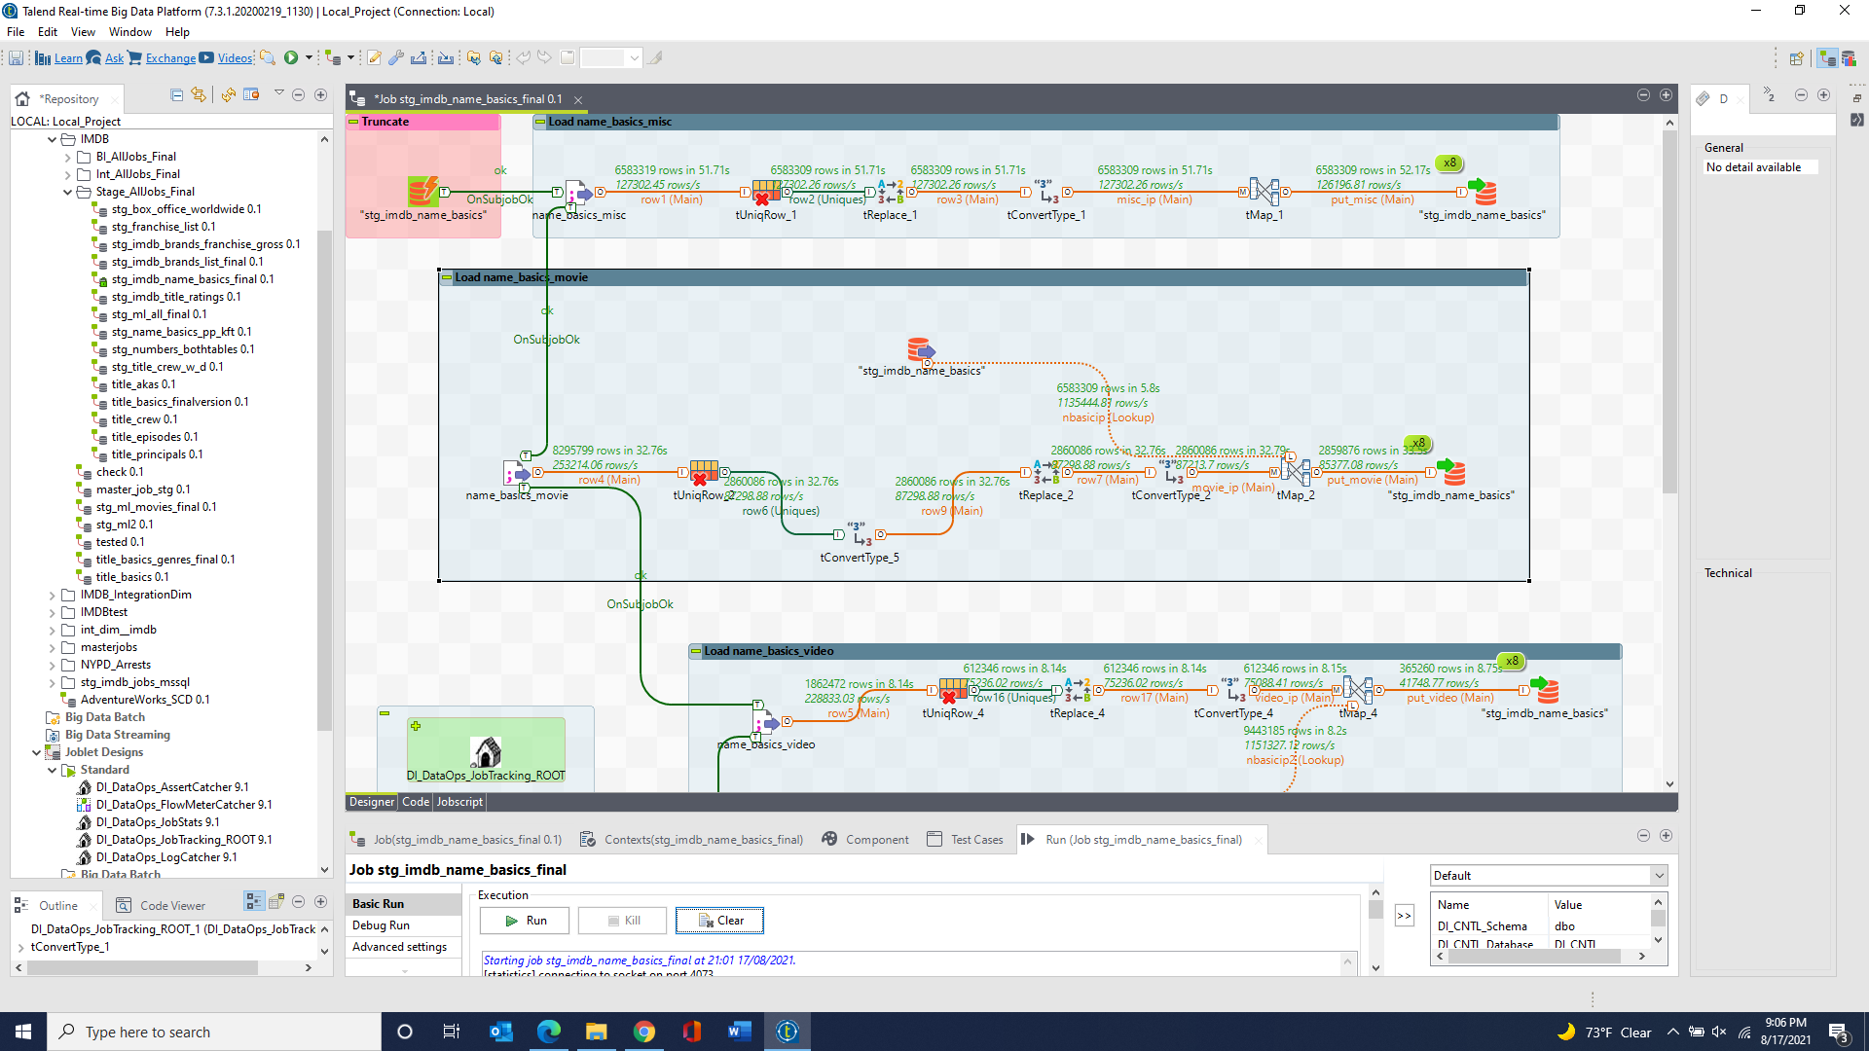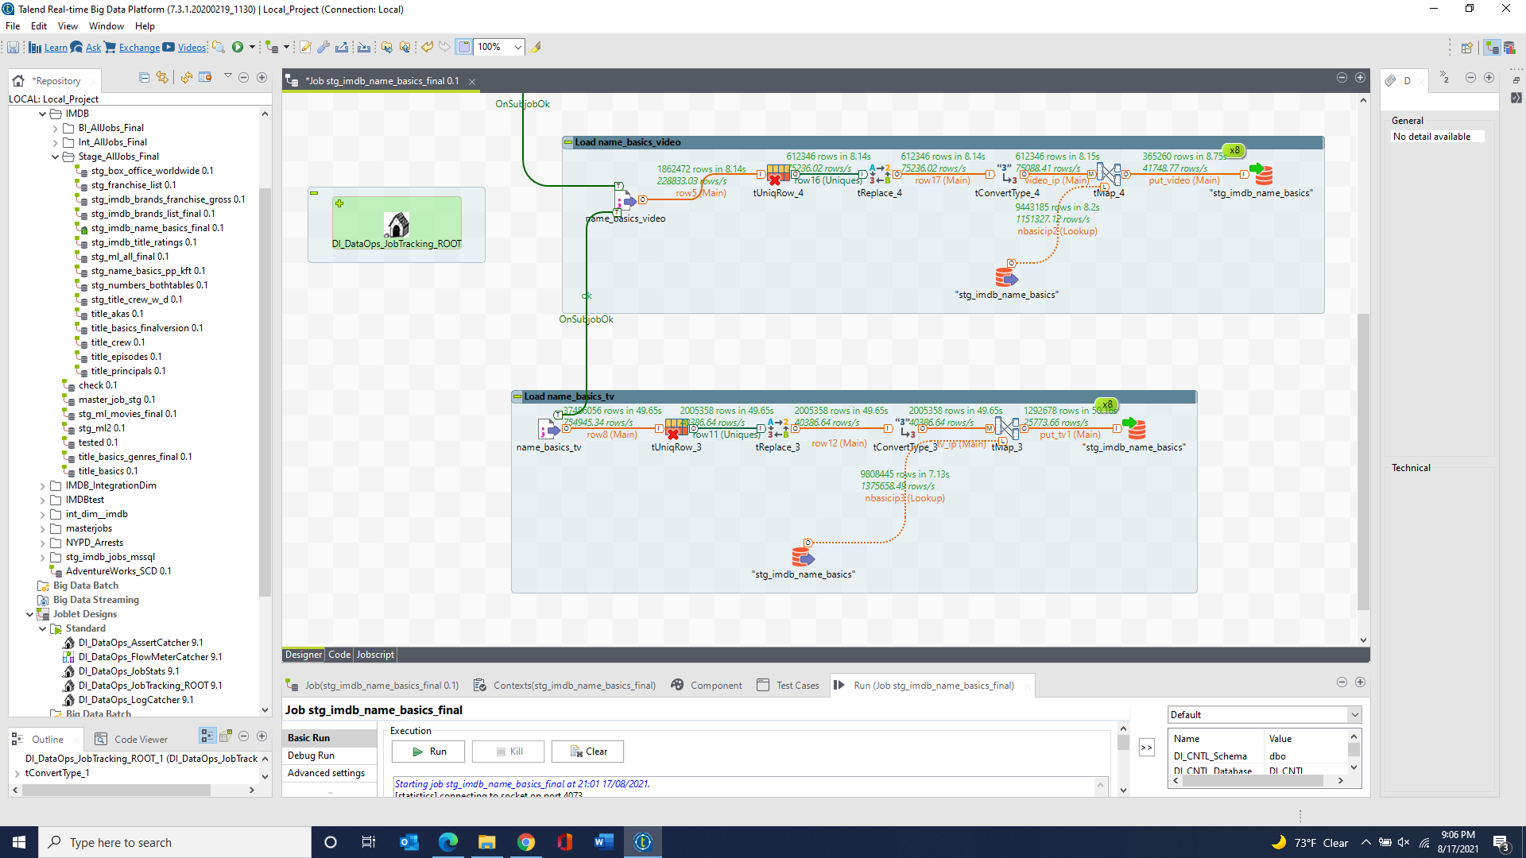

stg_imdb_name_basics_knownForTitles & stg_imdb_name_basics_primaryProfession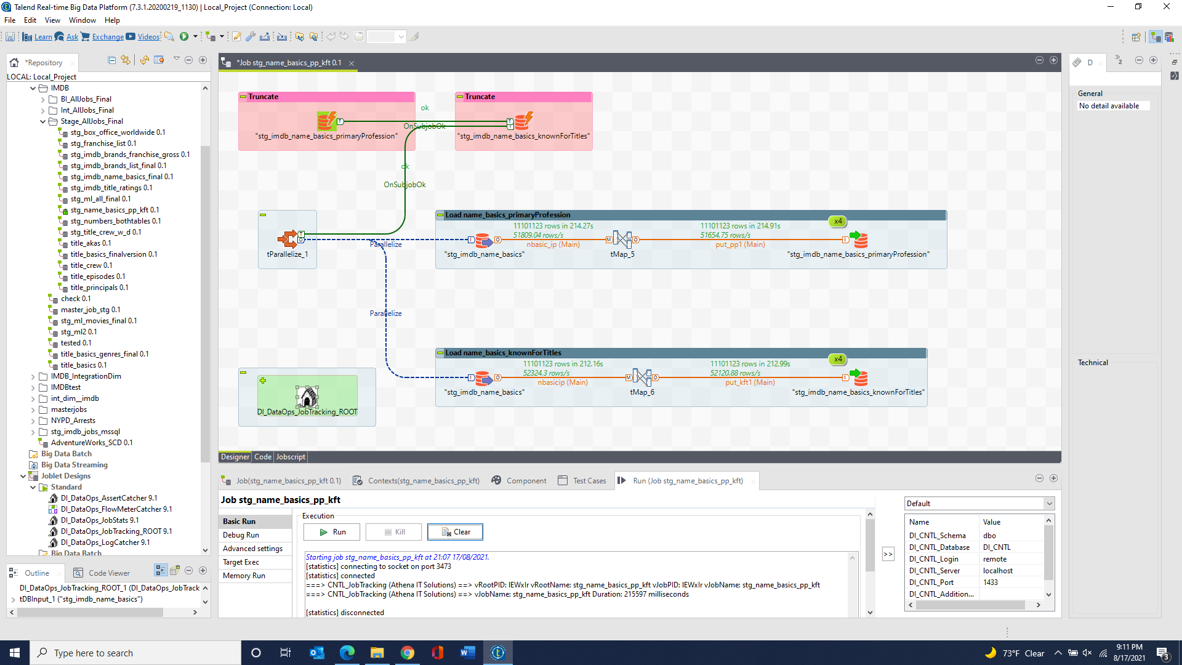

stg_imdb_title_akas 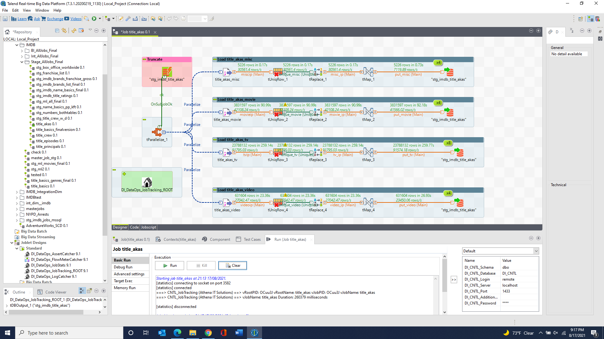

stg_imdb_title_basics & stg_imdb_title_basics_genres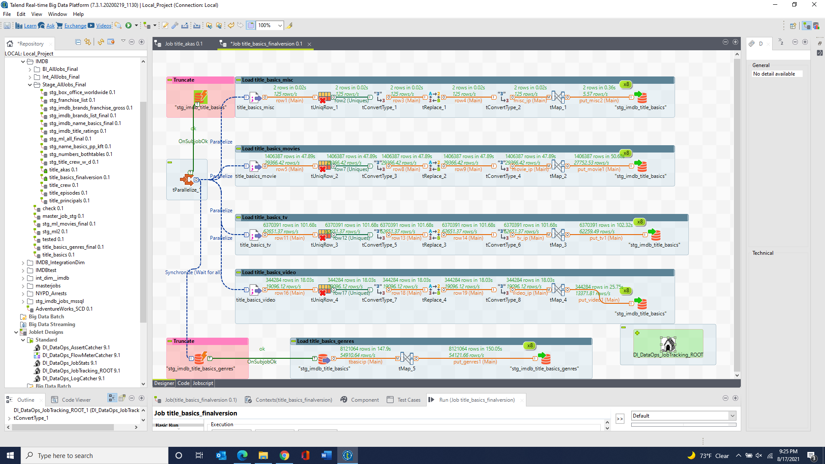

stg_imdb_title_crew 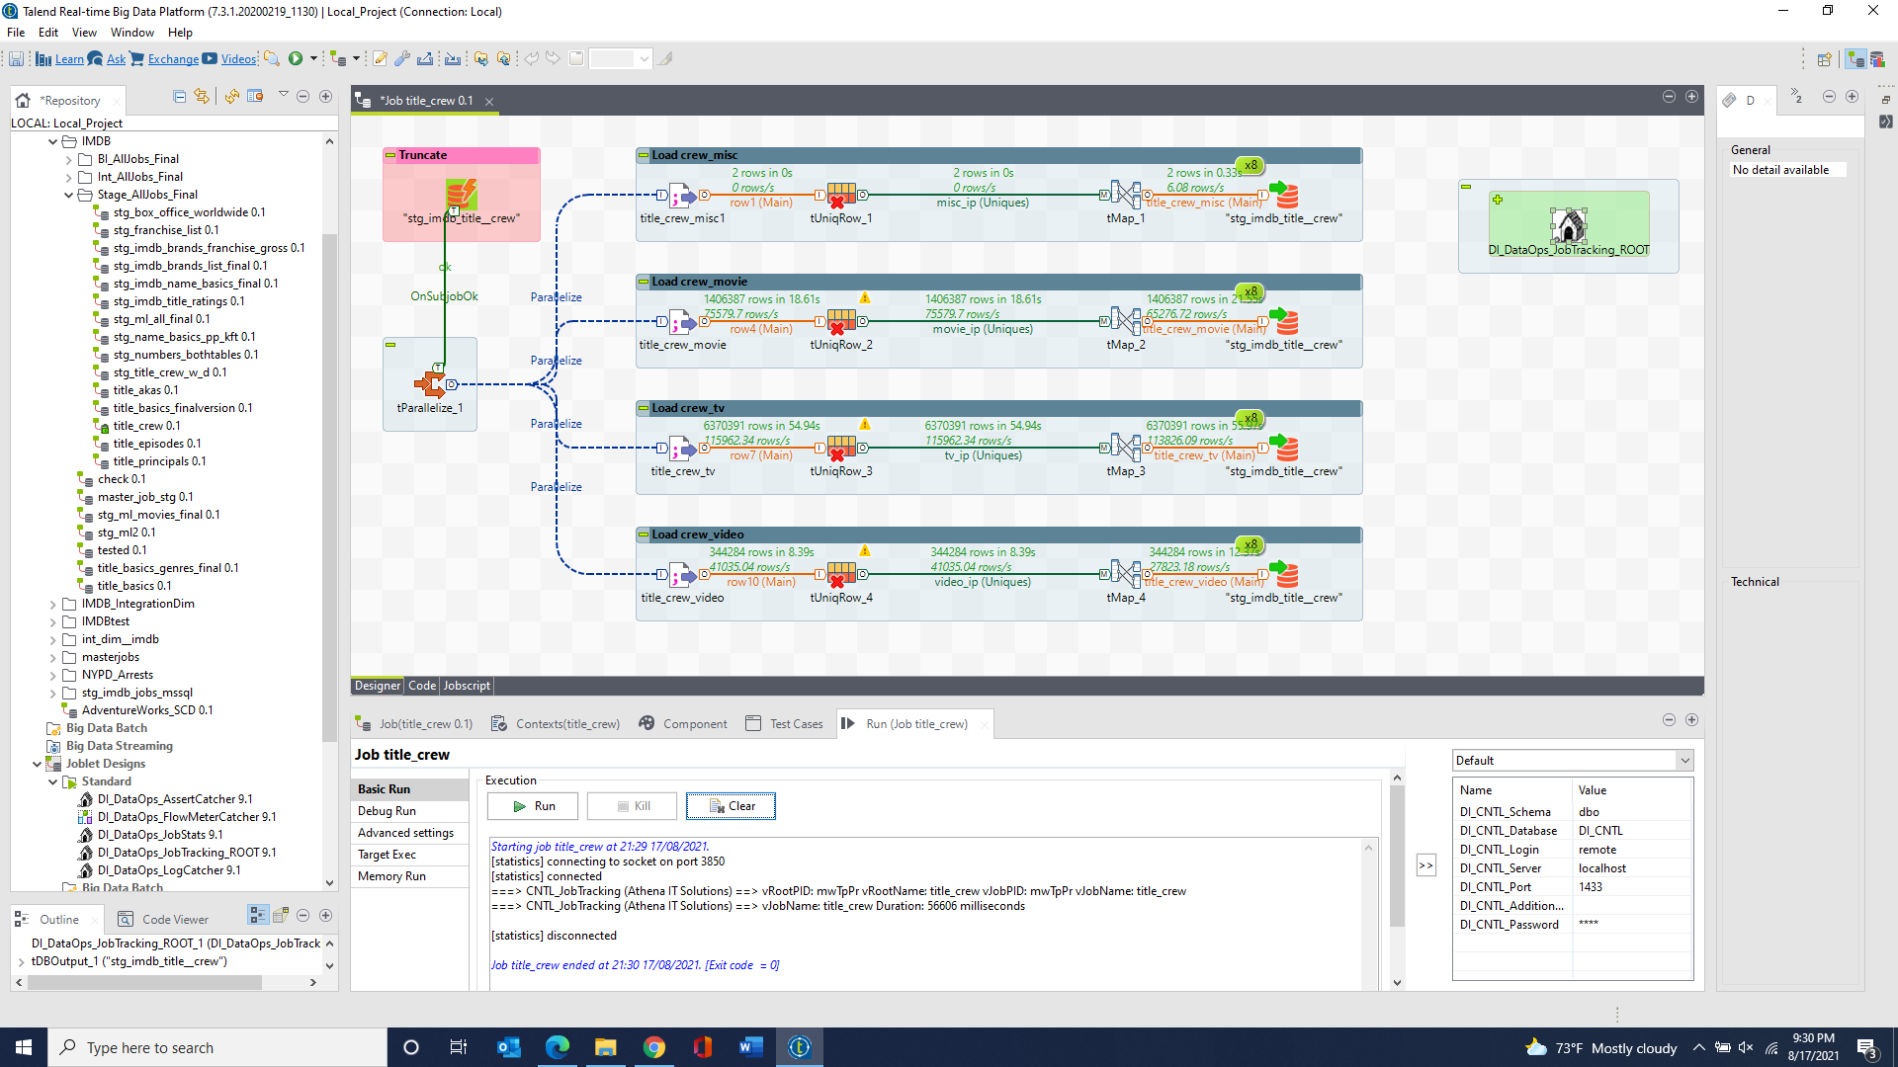

stg_imdb_title_crew_directors & stg_imdb_title_crew_writers 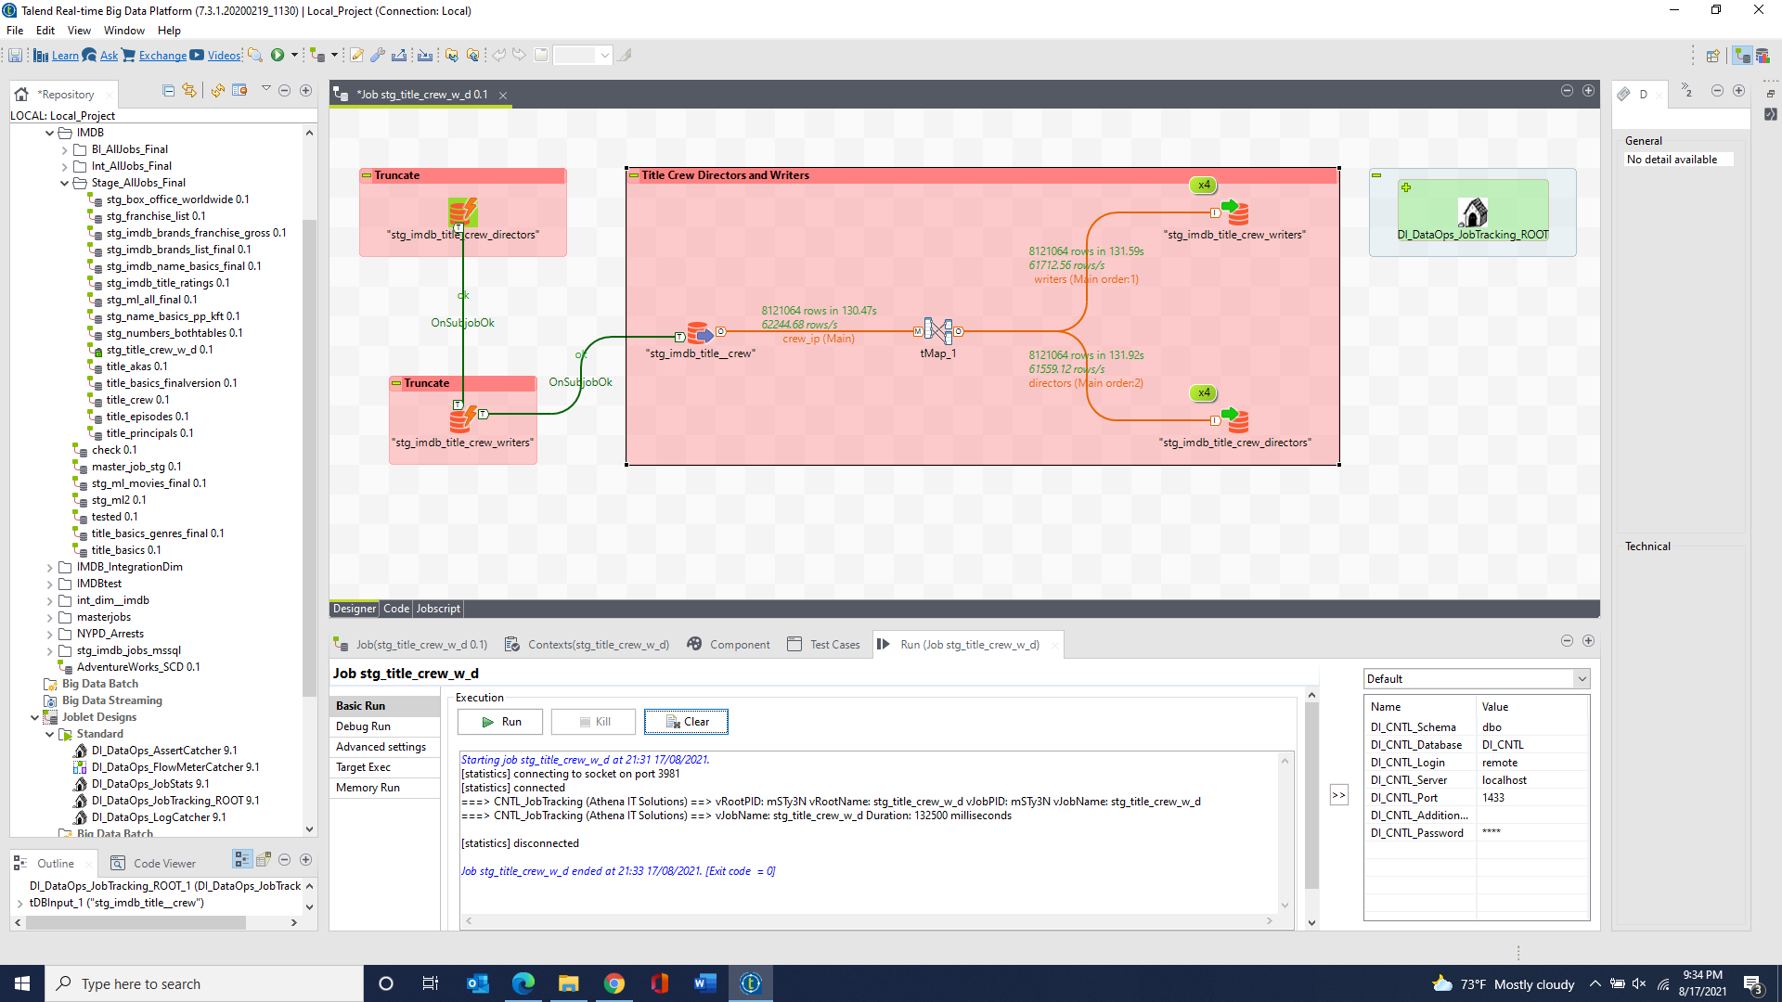

stg_imdb_title_episode 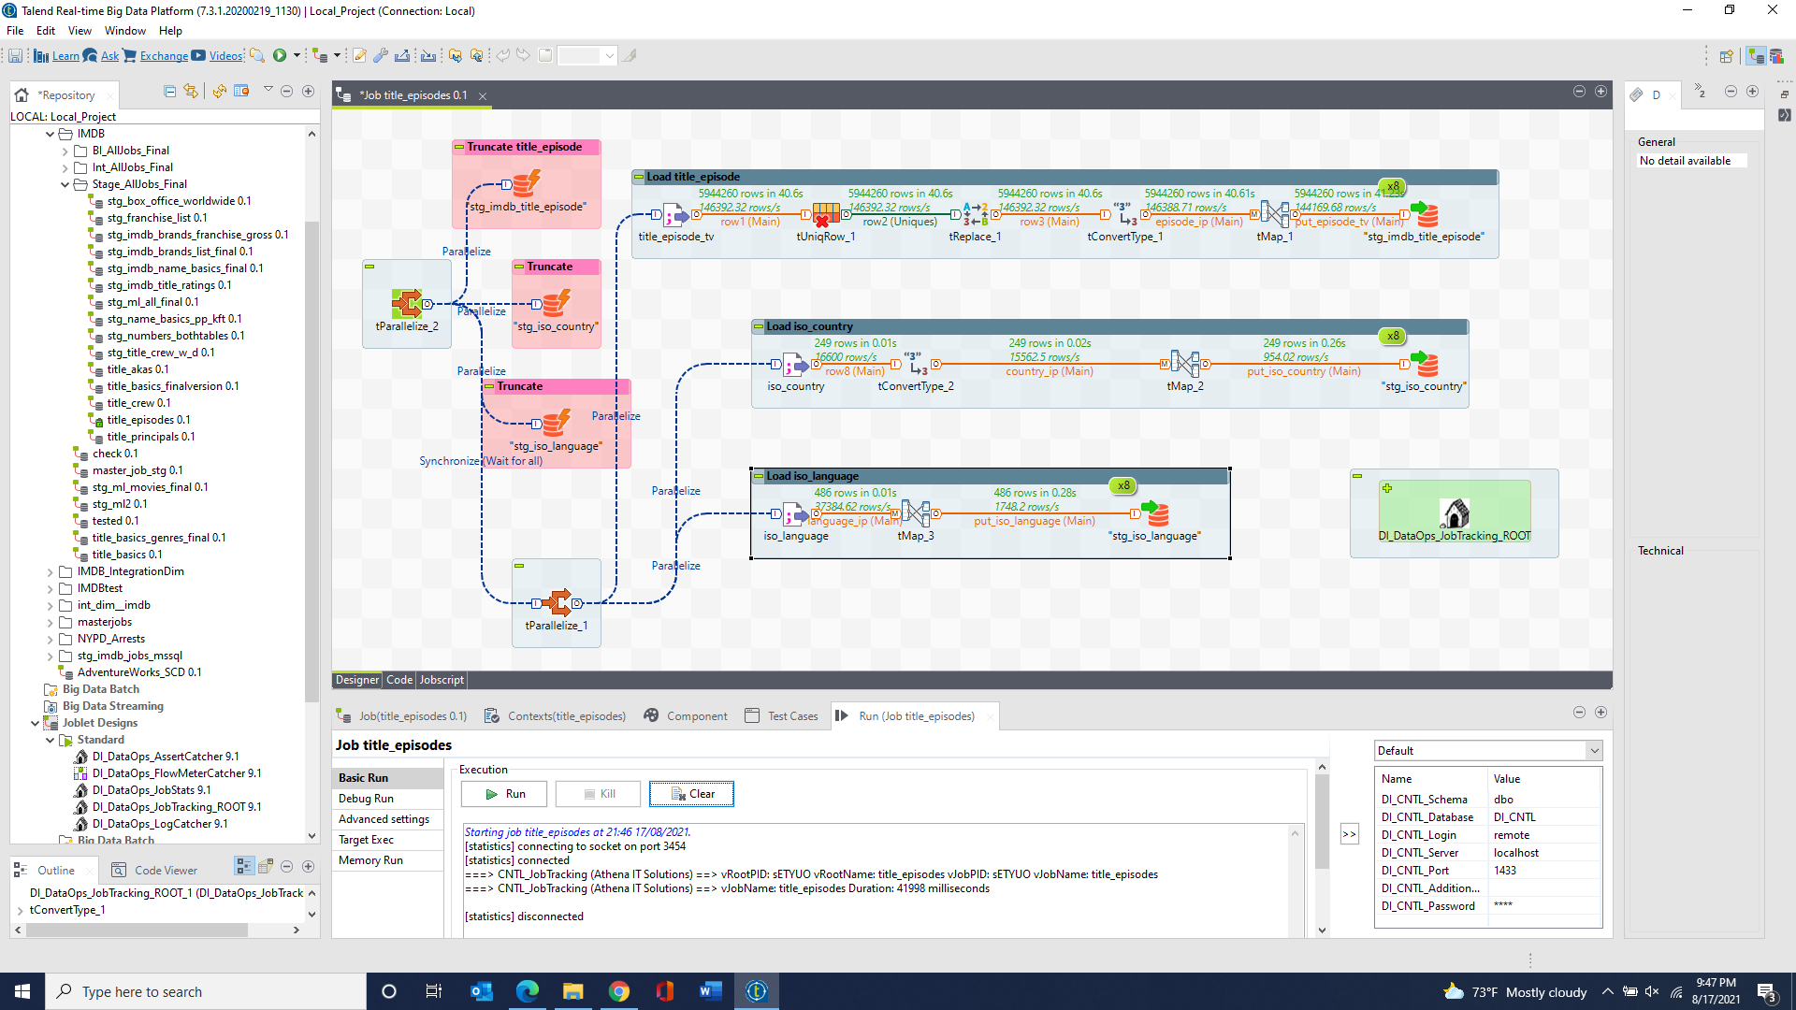

stg_imdb_title_principals 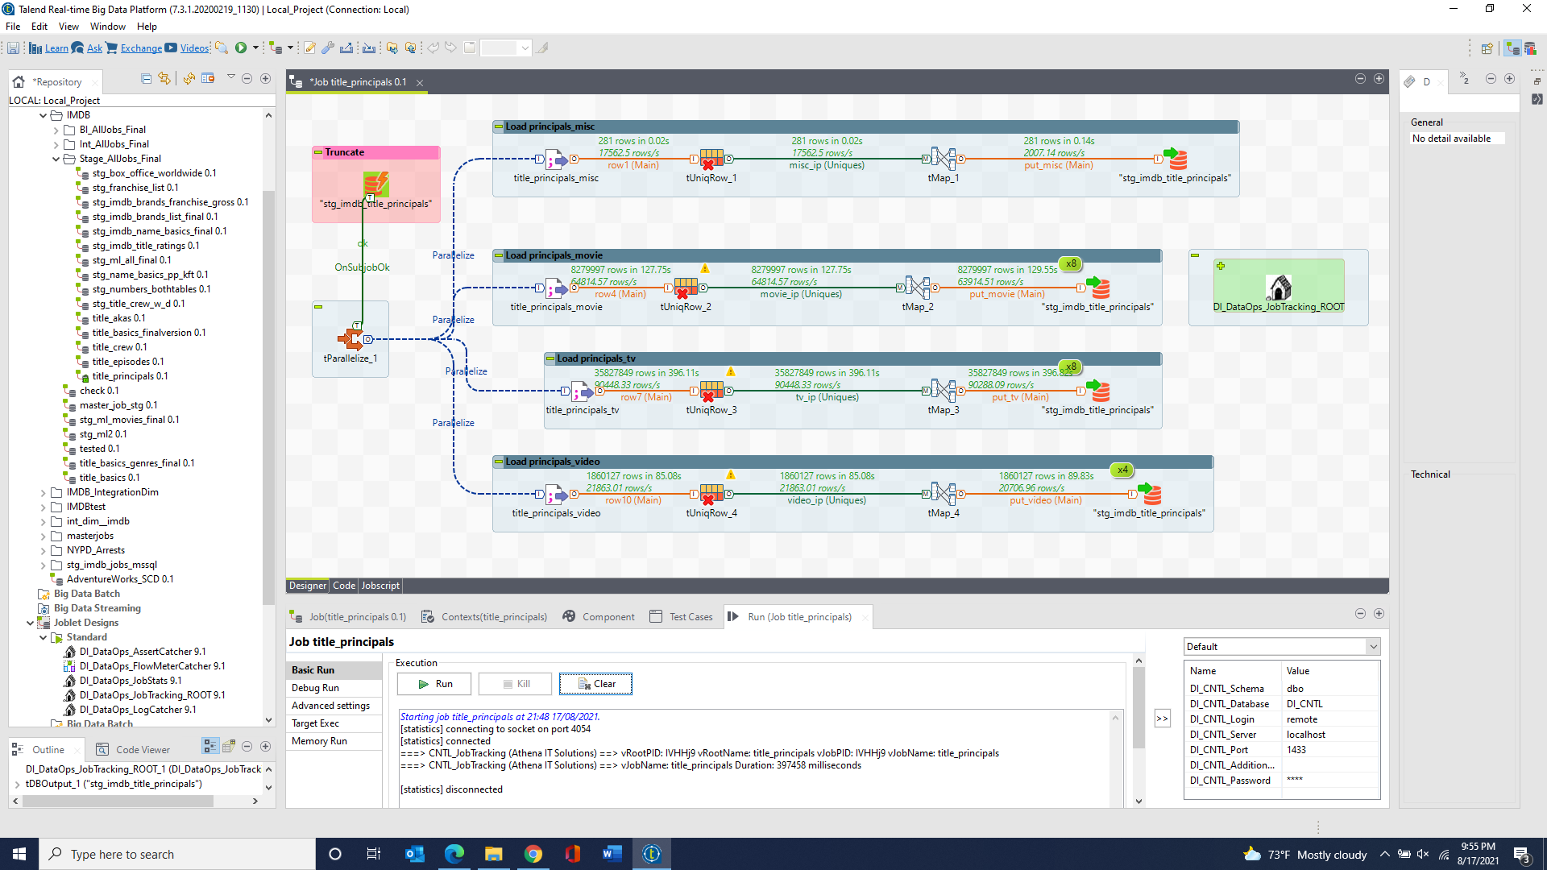

stg_imdb_title_ratings 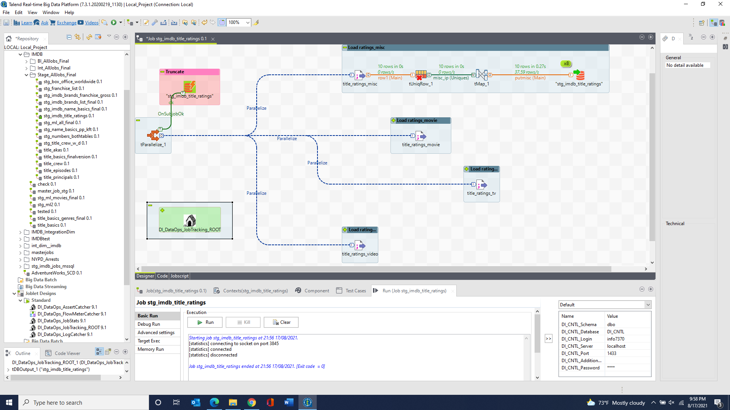 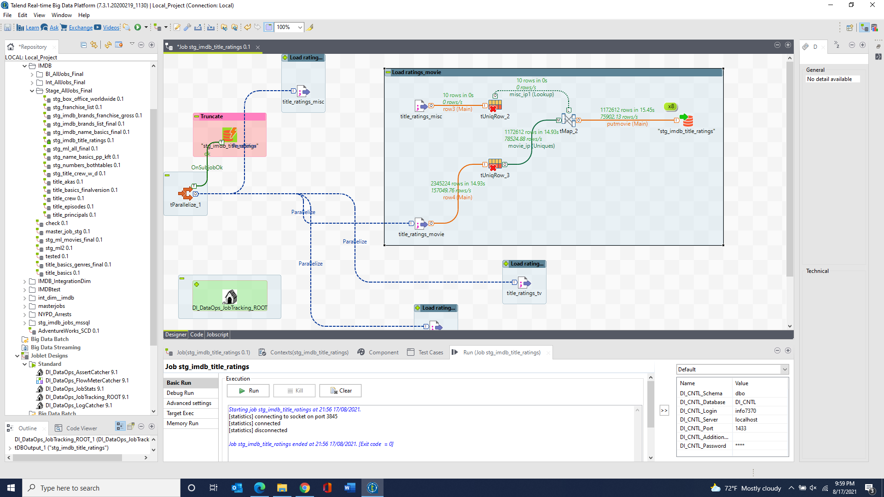 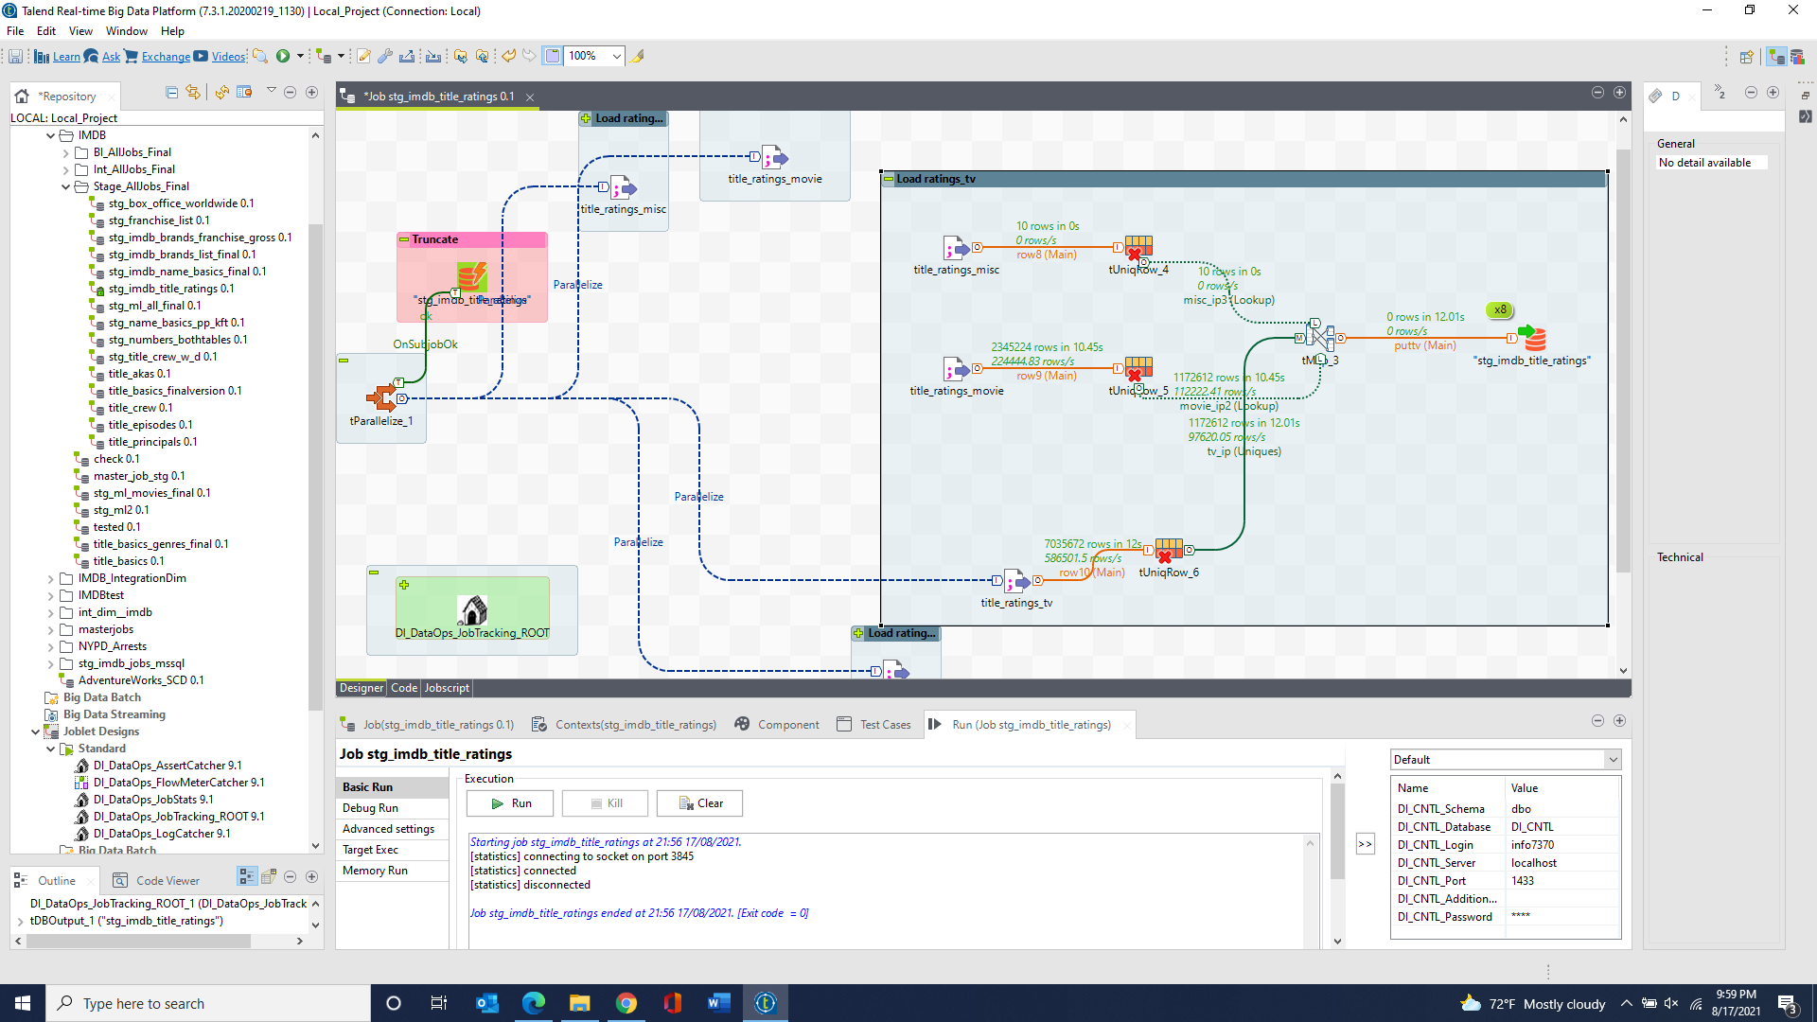 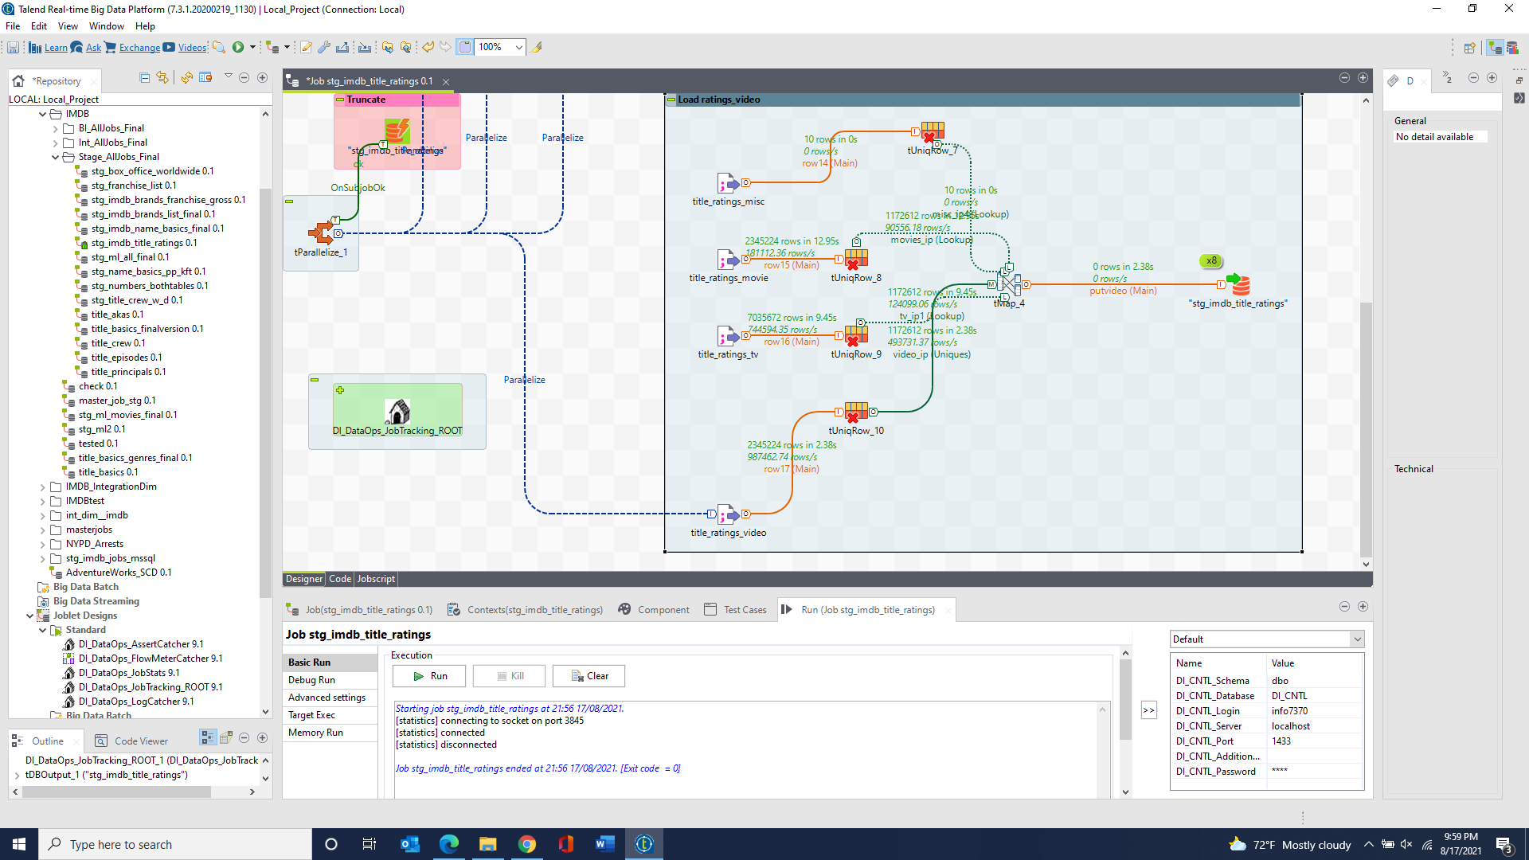

stg_iso_country & stg_iso_language & stg_ml_genome_scores & stg_ml_genome_tags & stg_ml_links & stg_ml_movies & stg_ml_ratings & stg_ml_tags 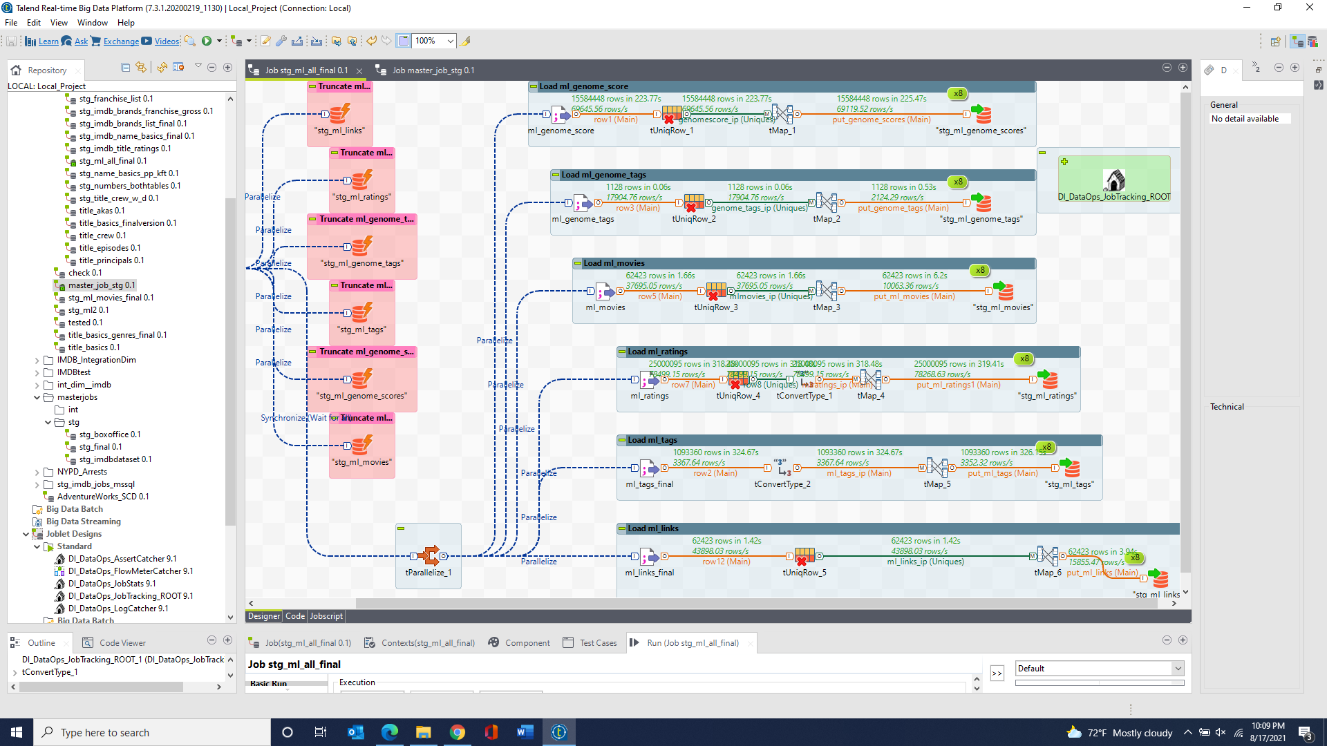

stg_numbers_daily_box_office & stg_numbers_frachise_all_box_office & stg_numbers_daily_box_office_V2